**NAME:GOGULA KUMAR M**

**ROLLNO:727721EUIT040**

**CLASS:IT-A**

**CLASS EXERCISE 2:**

**Eclipse code:**

package com.selenium.test2.selenium1;

import org.openqa.selenium.By;

import org.openqa.selenium.WebDriver;

import org.openqa.selenium.WebElement;

import org.openqa.selenium.chrome.ChromeDriver;

import org.openqa.selenium.chrome.ChromeOptions;

//import org.openqa.selenium.edge.EdgeDriver;

import io.github.bonigarcia.wdm.WebDriverManager;

/**

* Hello world!

*

*/

public class App

{

public static void main( String[] args ) throws InterruptedException

{

WebDriverManager.chromedriver().setup();

ChromeOptions co=new ChromeOptions();

co.addArguments("--remote-allow-origins=*");

WebDriver driver=new ChromeDriver(co);

driver.get("https://demo.opencart.com/index.php?route=account/register&language=en-gb");

driver.manage().window().maximize();

WebElement fn=driver.findElement(By.id("input-firstname"));

System.out.println(fn);

WebElement ln=driver.findElement(By.id("input-lastname"));

System.out.println(ln);

WebElement em=driver.findElement(By.id("input-email"));

System.out.println(em);

WebElement pass=driver.findElement(By.id("input-password"));

System.out.println(pass);

WebElement sub=driver.findElement(By.id("input-newsletter-yes"));

System.out.println(sub);

driver.findElement(By.className("gN089b")).submit();

}

}

**OUTPUT:**

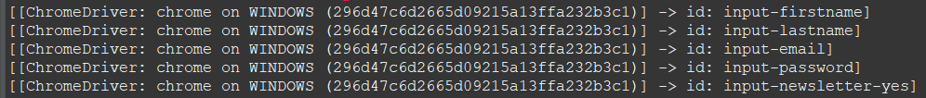

**CLASS EXERCISE 3:**

**Eclipse Code:**

package com.selenium.test2.selenium1;

import org.openqa.selenium.By;

import org.openqa.selenium.WebDriver;

import org.openqa.selenium.WebElement;

import org.openqa.selenium.chrome.ChromeDriver;

import org.openqa.selenium.chrome.ChromeOptions;

//import org.openqa.selenium.edge.EdgeDriver;

import io.github.bonigarcia.wdm.WebDriverManager;

/**

* Hello world!

*

*/

public class App

{

public static void main( String[] args ) throws InterruptedException

{

WebDriverManager.chromedriver().setup();

ChromeOptions co=new ChromeOptions();

co.addArguments("--remote-allow-origins=*");

WebDriver driver=new ChromeDriver(co);

driver.get("https://demo.opencart.com/index.php?route=checkout/voucher&language=en-gb");

driver.manage().window().maximize();

WebElement name=driver.findElement(By.xpath("//*[@id=\"input-to-name\"]"));

System.out.println(name);

WebElement email=driver.findElement(By.xpath("//*[@id=\"input-to-email\"]"));

System.out.println(email);

WebElement yourname=driver.findElement(By.xpath("//*[@id=\"input-from-name\"]"));

System.out.println(yourname);

WebElement msg=driver.findElement(By.xpath("//*[@id=\"input-message\"]"));

System.out.println(msg);

}

}

**OUTPUT:**



**CLASS EXERCISE 1:**

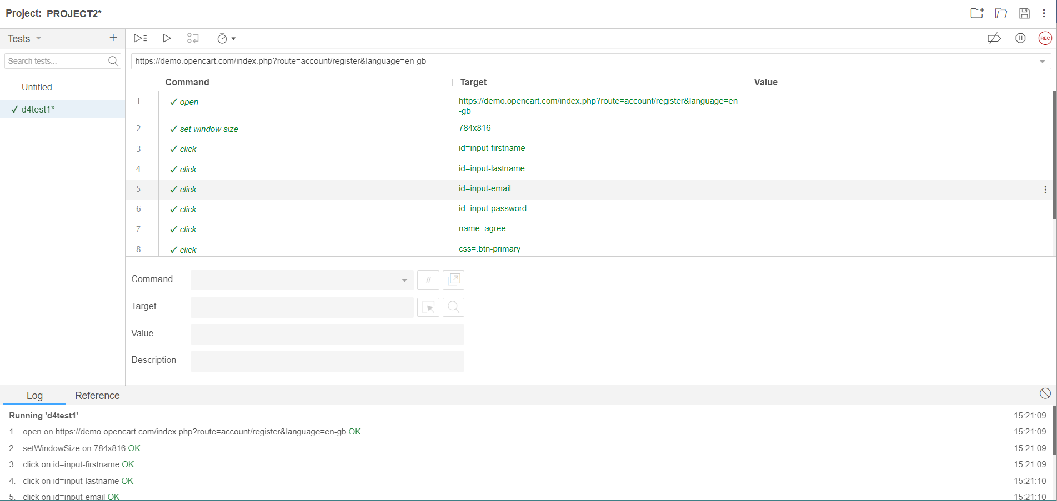

**CLASS EXERCISE 4:**

**Code for eclipse:**

package com.selenium.test2.selenium1;

import org.openqa.selenium.By;

import org.openqa.selenium.JavascriptExecutor;

import org.openqa.selenium.WebDriver;

import org.openqa.selenium.WebElement;

import org.openqa.selenium.chrome.ChromeDriver;

import org.openqa.selenium.chrome.ChromeOptions;

//import org.openqa.selenium.edge.EdgeDriver;

import io.github.bonigarcia.wdm.WebDriverManager;

/**

* Hello world!

*

*/

public class App

{

public static void main( String[] args ) throws InterruptedException

WebDriverManager.*chromedriver*().setup();

ChromeOptions co=new ChromeOptions();

co.addArguments("--remote-allow-origins=*");

WebDriver driver=new ChromeDriver(co);

driver.get("https://j2store.net/free/");

driver.manage().window().maximize();

driver.get("https://j2store.net/free/");

driver.manage().window().maximize();

JavascriptExecutor js=(JavascriptExecutor) driver;

js.executeScript("window.scrollBy(0,1000)","");

driver.findElement(By.*linkText*("Clothing (5)")).click();

driver.navigate().back();

driver.navigate().forward();

driver.navigate().refresh();

driver.quit();

**OUTPUT:**

Navigation backward in browser history.

Navigation forward in browser history.

Refresh/Reload a web page.

**CLASS EXERCISE 5.1:**

**Eclipse code:**

package com.selenium.test2.selenium1;

import java.util.List;

import org.openqa.selenium.By;

import org.openqa.selenium.JavascriptExecutor;

import org.openqa.selenium.WebDriver;

import org.openqa.selenium.WebElement;

import org.openqa.selenium.chrome.ChromeDriver;

import org.openqa.selenium.chrome.ChromeOptions;

//import org.openqa.selenium.edge.EdgeDriver;

import io.github.bonigarcia.wdm.WebDriverManager;

/**

* Hello world!

*

*/

public class App

{

public static void main( String[] args ) throws InterruptedException

{

WebDriverManager.*chromedriver*().setup();

ChromeOptions co=new ChromeOptions();

co.addArguments("--remote-allow-origins=*");

WebDriver driver=new ChromeDriver(co);

driver.get("https://j2store.net/free/");

driver.manage().window().maximize();

driver.get("https://j2store.net/free/");

driver.manage().window().maximize();

JavascriptExecutor js=(JavascriptExecutor) driver;

js.executeScript("window.scrollBy(0,1000)","");

String url1="https://j2store.net/free/";

String url2="";

url2=driver.getCurrentUrl();

if(url1.equals(url2))

System.***out***.println("Correct 1st page");

driver.findElement(By.*linkText*("Clothing (5)")).click();

url1=driver.getCurrentUrl();

if(url1.equals("https://j2store.net/free/index.php/shop?filter_catid=11"));

System.***out***.println("Correct 2nd page");

driver.navigate().back();

driver.navigate().forward();

driver.navigate().refresh();

driver.quit();

}

}

}

}}}]}}}}]}

**OUTPUT:**

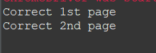

**CLASS EXERCISE 5.2:**

**Eclipse code:**

package com.selenium.test2.selenium1;

import java.util.List;

import org.openqa.selenium.By;

import org.openqa.selenium.JavascriptExecutor;

import org.openqa.selenium.WebDriver;

import org.openqa.selenium.WebElement;

import org.openqa.selenium.chrome.ChromeDriver;

import org.openqa.selenium.chrome.ChromeOptions;

//import org.openqa.selenium.edge.EdgeDriver;

import io.github.bonigarcia.wdm.WebDriverManager;

/**

* Hello world!

*

*/

public class App

{

public static void main( String[] args ) throws InterruptedException

{

WebDriverManager.*chromedriver*().setup();

ChromeOptions co=new ChromeOptions();

co.addArguments("--remote-allow-origins=*");

WebDriver driver=new ChromeDriver(co);

//open link and maximize

driver.get("https://j2store.net/free/");

driver.manage().window().maximize();

JavascriptExecutor js=(JavascriptExecutor) driver;

js.executeScript("window.scrollBy(0,1000)","");

driver.findElement(By.*linkText*("Clothing (5)")).click();

Thread.*sleep*(5000);

List<WebElement> l1=driver.findElements(By.*xpath*("//h2[@class='product-title']"));

for(WebElement link:l1)

{

System.***out***.println(link.getText());

}

}

}

**OUTPUT:**











